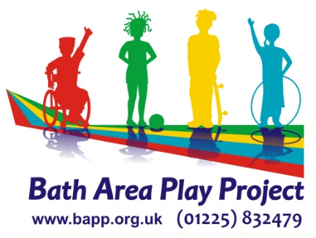

VOLUNTEER APPLICATION FORM

Name _______________________________ Date of Birth ____________

Address ____________________________________________________

___________________________________ Postcode _______________

Email address ______________________________________________

Telephone No. _______________________________________________

Have you volunteered for BAPP before? ___________________________

If YES, please give details ie Easter / Summer / Year
___________________________________________________________

How did you hear about volunteering for BAPP?
___________________________________________________________

What experience of working, especially with children, have you had?

___________________________________________________________

___________________________________________________________

Please tick a box for the type of volunteering you wish to do:

- Community Playdays (Spring / Summer school holidays): Bath  Keynsham  Midsomer Norton  All 
b) Closed access holiday playschemes: The Hut, Twerton  
Somer Centre  Three Ways 
c) Saturday Club Primary  
d) Saturday Club Secondary 
e) Pre-school at the Hut, Twerton   f) Family Play Hub Groups 
g) Social Media  h) Office Admin   

I have read and understood the enclosed Staff and Volunteer Code of Conduct and Declaration of Non-Discriminatory Practice, and will abide by this whilst at the setting.

Signed___________________________________ Date__________________

Please write the Names and Addresses of two people who we can contact for a reference for you.

Name __________________________ Name __________________________

Address ________________________ Address _________________________

_______________________________ ________________________________

_______________________________ ________________________________

Email address:___________________ Email address:_____________________

Post Code ______________________ Post Code________________________

Telephone No. __________________ Telephone No. _____________________

How do they know you? ___________ How do they know you? _____________

______________________________ _________________________________

Please let us know if there is anything we should know about you in order to support you to volunteer with us:

Do you hold an Enhanced DBS Disclosure? Yes / No

If No, would you be willing to complete one? Yes / No

If Yes, please bring your certificate with you when you meet the Director.

Please return this form to: Bath Area Play Project, Odd Down Community Centre, Bath BA2 2TL or save as and return as an attachment

Office Use Only

 | Date received / completed | Seen / approved
Reference 1
Reference 2
DBS
Code of practice
Declaration of ADP

