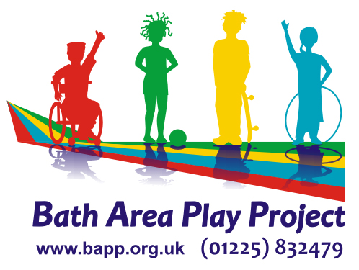

**REGISTRATION FORM**

*Please can you fill out all sections & let us know if there are any changes*

Child’s Name ……………….……………………………………… Date of Birth …………………………

Address…………………………………………………………………………………………………………

……………………………………………………………………………Post Code ………………………

Email ………………………………………………Telephone No ………………………………………..

Parent / Carer’s Name: ……………………………..Mobile No…………………………………………..

Who has parental responsibility for the child/ young person? ……………………………………………

No. 1 Emergency Contact Name & No (NOT PARENT) …………………………………………………

No. 2 Emergency Contact Name & No (NOT PARENT) ………………………………………………..

Doctors Name & telephone number ……………………………………………………………………….

Child’s current school/setting…………………………………………… Which Year Group?………………….

Name of Social Worker (if applicable) ………………………………………………….

Would you be happy for the play provider to talk to your Social Worker/School? YES NO

Does your child meet the **eligibility criteria** (see attached)? YES NO

**Medical Conditions**/**allergies/medication** taken:

Does the child/young person need to **take medication** whilst they are with us? Yes No

Does your child have epilepsy? Yes  No  If yes, when was their last seizure?…………...

Does your child have any allergies? Yes  No  If yes, what?

Where 8+ years, does your child receive **benefit related** free school meals ? Yes  No 

**Dietary requirements** / Is your child tube fed? Please enclose Feed Plan

**Portrait of your child** – What do they **like doing? What needs do they have?**

Do they have an EHC Plan? Yes  No  If Yes, please attach a copy - Tick if attached 

**Portrait of your child** - **Dislikes** (e.g. smells, noise, activities): **Anything that makes them upset?**

**How do you support your child when upset? What works for you? (Do they scream, scratch, pinch and what helps calm them down?) Are there any behaviours we should be aware of ?**

**Are there any strategies or best ways to support your child** and encourage positive behaviour? (Please give any tips/strategies when supporting)

**Communication Is your child non-verbal? Do they use Makaton, PECS or any other form of communication?**

**Brief description of additional needs e.g. support with toileting/eating. Do they try to escape?** Please note we are **do not** offer 1-1 support, but welcome PA’s where arranged by the family

**Data Protection Act 1998 & GDPR 2016** All information held about you will be kept secure and will only be used for data analysis for Funders or to send you relevant information about Short Breaks services. Data will be held confidentially for a minimum of one year or longer dependant on how long you use the service. You have the right to withdraw consent at any time. Please see our Privacy Notice [www.goo.gl/4sbf28](http://www.goo.gl/4sbf28)

**Your consent:**

I consent to the provider sharing information with other commissioned play/short break providers

I consent to data information being used for the purposes of running the service your child attends.

I consent to my child having photos/being filmed and possibly used to help promote the service

I give permission for my child_________________ to attend the holiday playscheme and to participate

in all activities that are available including soft play, bikes, bouncy castle, and visiting local shops & parks.

I understand playscheme staff cannot accept responsibility for children’s possessions or valuables.

I consent to any emergency treatment to be carried out in case of accident and that my child is the responsibility of the playscheme staff.

Signed: ­­­­­­­­­­­­­­­­­­­­_________________________ Date: _____________________________________

Name __________________________ Relationship to child _________________________